DOCUMENTATION

ASSIGNMENT 2 – DISTRIBUTED SYSTEMS

STUDENT: ANDREEA-LAVINIA GAVRILESCU
GROUP: 30242

CUPRINS

1. The objective of the theme 3
2. Problem analysis, modeling, scenarios, use cases 3
3. Design 3
4. Implementation 3
5. Results 3
6. Conclusions 3
7. Bibliography 3

The objective of the theme

Main obejective
- Develop an Monitoring and Comuunication System Microservice that consists in syncronizing with the Device microservice and a Smart Metering Device Simulator designed to compute the hourly energy consumption and stores it in the database.

Secondary objectives
- Problem analysis and requirements identification
- Designing the microservices and an associated frontend
- Implementation of the microservice and application and updating the other microservice
- Testing the both of the microservices

Aproblem analysis, modeling, scenarios, use cases

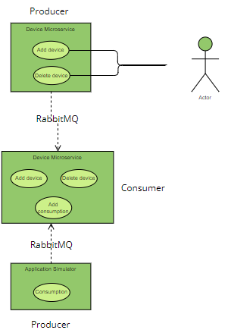

Functional requirements
- The microservice should receive data from the Simulator application through RabbitMQ.
- The Device microservice should send information when adding/deleting a device to the RabbitMQ and the microservice should update the database accordingly.
- The final application with all the modules should be deployed on Docker.

Non-functional requirements
- The frontend should be interactive and easy to use.

Cazuri de utilizare
- Use case 1: add new device / delete a device
Actor: administrator
Main scenario
- The user needs to go to the Device Management page.
- The user needs to press the ADD DEVICE / DELETE DEVICE button.
- The user needs to complete the form that opens with correct information.
- The changes will be posted on the RabbitMQ and consumed by the new microservice which will perfom updates on the DB accordingly.
Alternative scenario
- The user could introduce wrong details.
- The scenario goes to step 3.

- Use case 2: add consumption
Actor: Simulator Application
Main scenario
- It posts on the queue the data read from the sensor.csv file.

Design

Architecture Diagram
- I will follow a layered architecture, because it separates the application into distinct layers, each responsible for specific functionalities so that a change in one layer doesn't necessarily require modifications in the others.

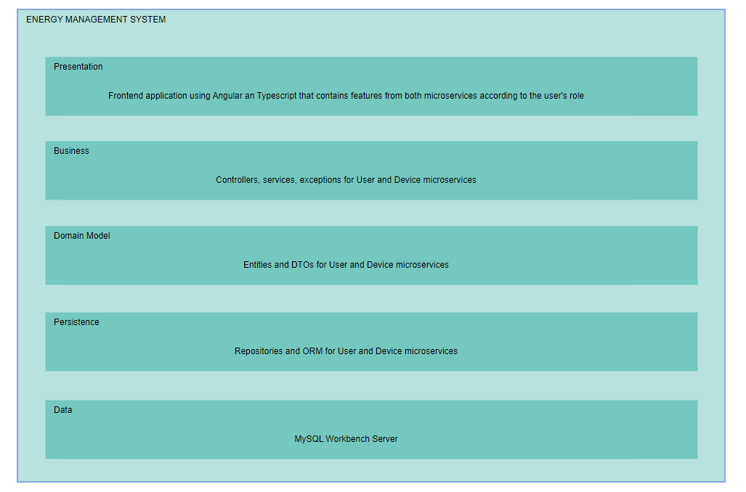

Package division
- Backend packages: domain(entity, dto), repository, service, exception, controller, security and utils (only for User microservice)

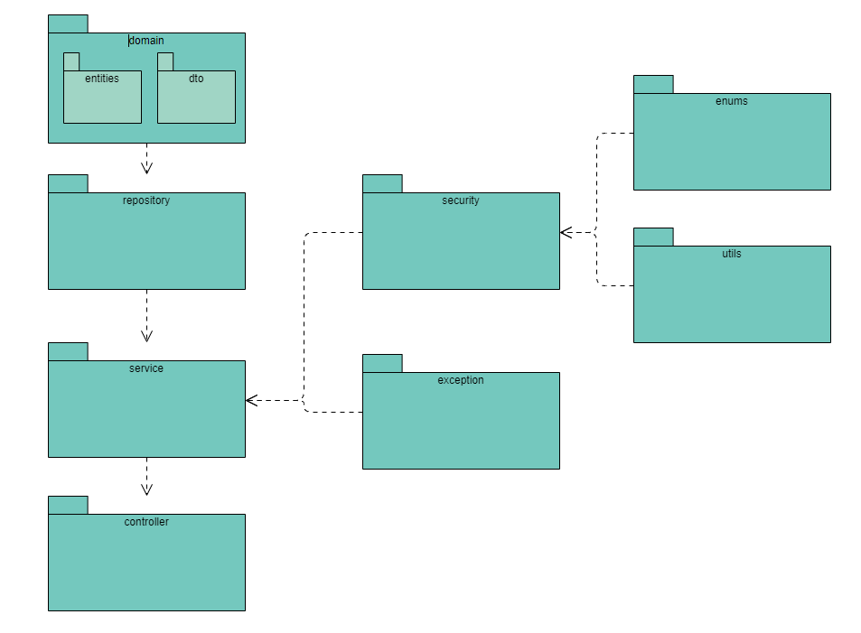
- Frontend structured in the following components: login, navbar, admin-menu, user-options, device-options, mapping options, user-devices
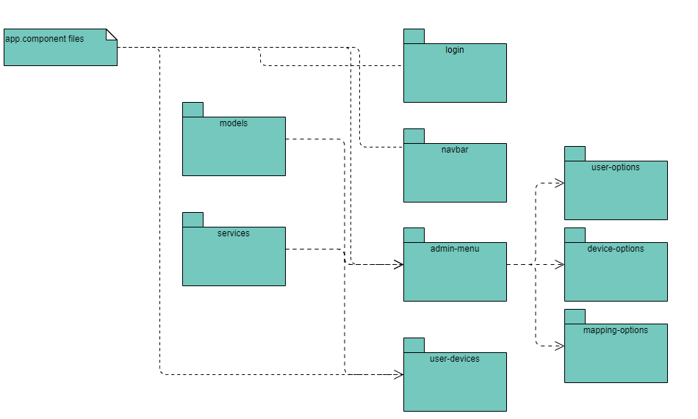

Implementation
For the backend I chose to use Java and Spring as framework.
For the database, I used MySQLWorkbench and Hibernate in order to create tables from my backend applications.
Device Microservice
- Database
- In this DB there are two tables: devices(device_id, address, consumption, description, user_id) and users_available(user_id).
- user_id is foreign key because we will need it when we add or delete a mapping.
- Posting messages on queue
- When an user adds / deletes a device, a message will be posted on the queue(format: deviceId, action = post/delete).
- The Monitoring and Communication Microservice will consume the message, meaning that it will perform operations on DB based on the received action type.

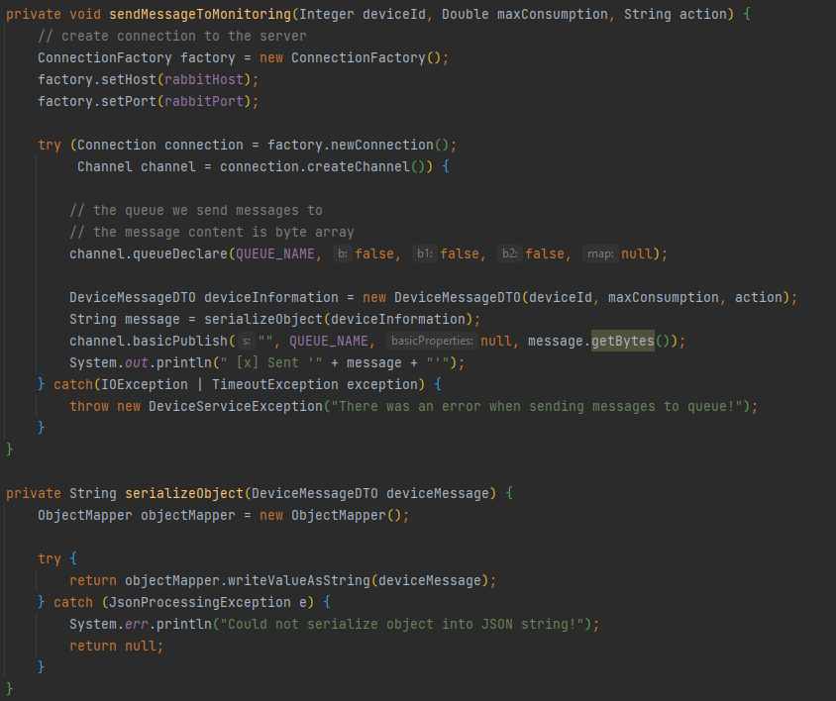

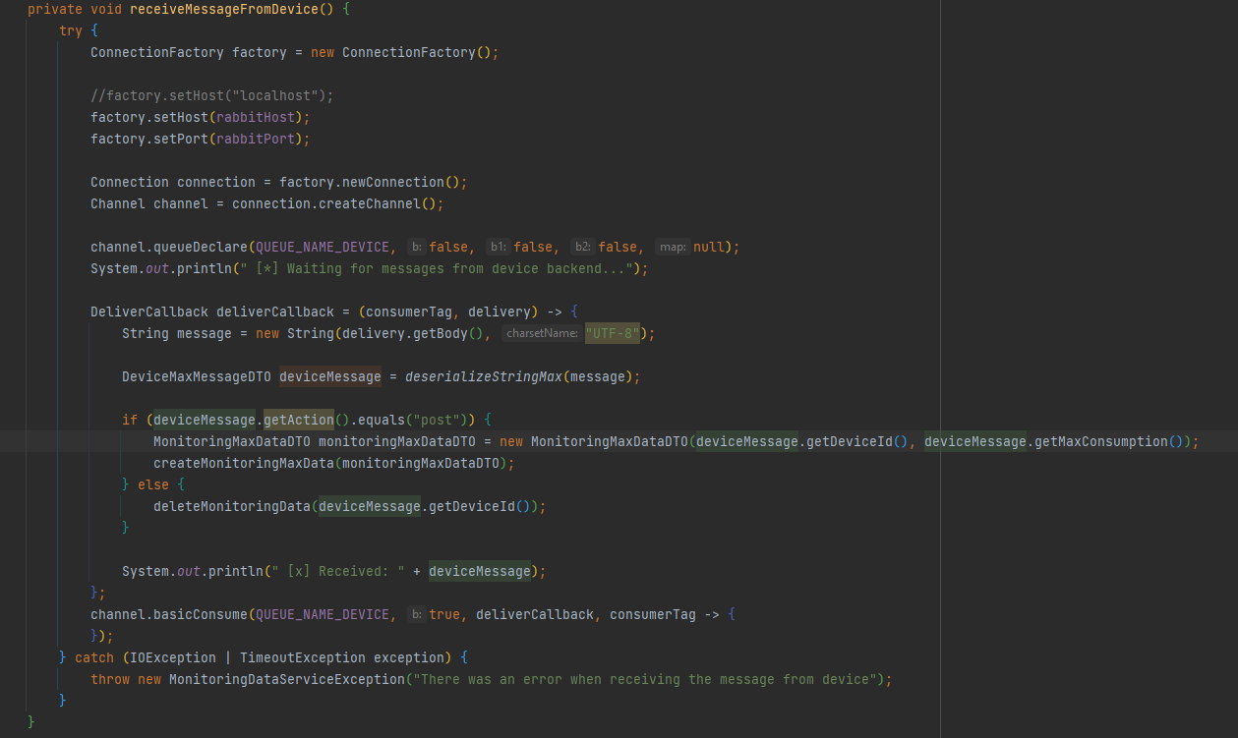
- In the Simulator App we read data from the script at every 10 minutes and post it on the queue so that Monitoring Microservice can consum it.

Frontend
- I implemented it using Typescript and Angular as framework. It is structered in components that communicate with each other.
- I intercepted the responses from the backend in the services and then used those methods in my components.
- The user will be redirected to the corresponding page according to its role which I identify from its authorization token.

Docker
- For the deployment of the application I created:
- Two volumes for the DBs and then two containers for the Device DB, Monitoring and Comunication DB.
- A container for each microservice and the Simulator Application.
- I needed some configurations in my application.yml and then a Dockerfile for each module.
- After creating images and containers from them, my application is hosted on docker now, I only need to start the containers.

Deployment diagram
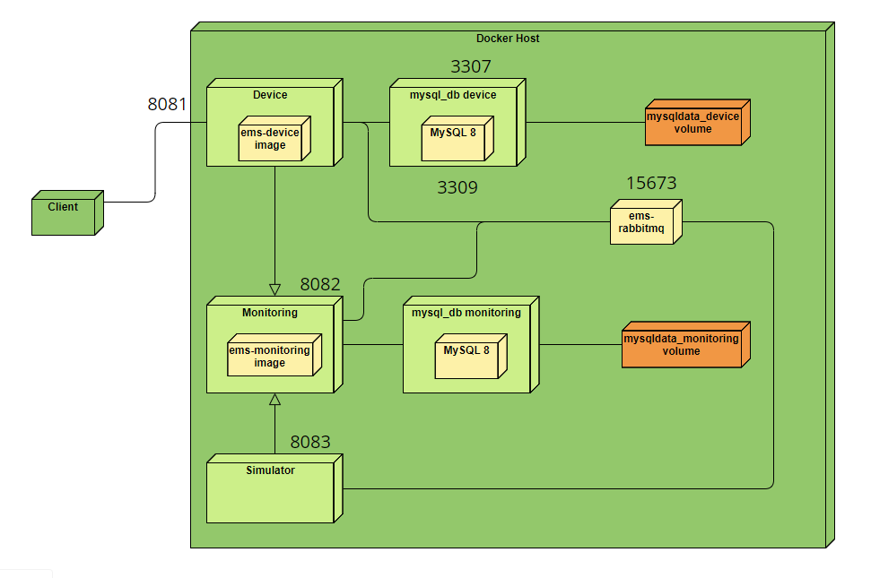

Results
For the testing part I used validation testing, meaning that I tested all the flows following the use-cases and verified if the changes are performed on the DB too.

Conclusions
In this assignment I got the chance to learn about deployment on Docker which I hopefully apply to my license. I also learned how to implement a communication mechanism between two microservices.

Bibliography
- https://docs.docker.com/language/java/deploy/
- https://medium.com/geekculture/how-to-create-and-deploy-docker-applications-1b00e4246c1d
- https://www.rabbitmq.com/tutorials/tutorial-one-java.html

